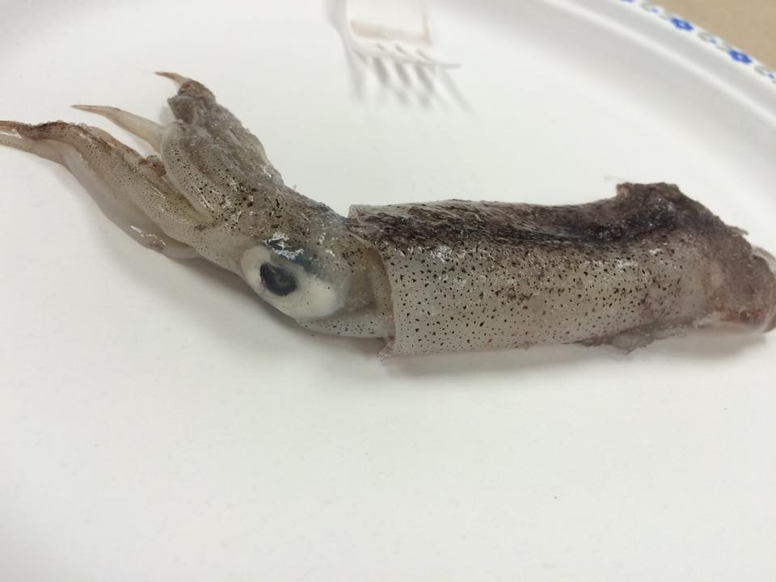

Arms

Tentacle

Mantle

Eye